Skipton – HDSRL
Start: Aireville Park @ 7:45pm
Parking: Park at Sandylands (Sat Nav: BD23 2AZ). The start is a short 5 minute walk from here.
Post-race: Refreshments and post-race gathering at Sandylands.
Route: The race starts in Aireville Park and heads out of the park at the war memorial entrance. It crosses Gargrave Road (A) and heads up Rockwood Drive/Raikeswood Drive (B). Runners will join White Hills Lane (C) and will continue all the way through Stirton and Thorlby to the A65 (D). After the turn point the runners will run alongside the A65 (E) before turning left onto Stirton Lane. Runners will then retrace their steps over White Hills and Raikeswood/Rockwood. They will then turn right along Gargrave Road before crossing again (F) to enter the park at the main entrance road (G).
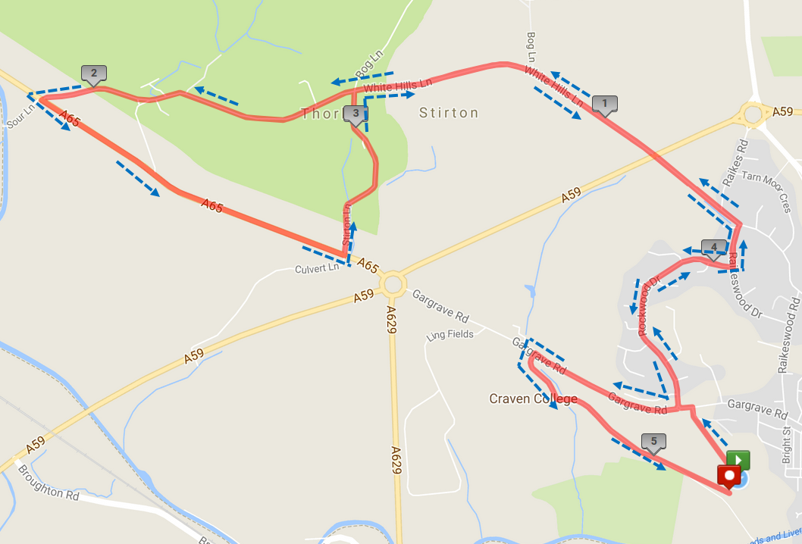
G
F
E
D
C
B
A
Special instructions relating to runner safety:
Please listen to advice from the marshals and do as they say. There are no road closures in place.
A – The first major road crossing. Due to its close proximity to the start we will try to get all runners across the road at once. Listen to, and abide by, marshal instructions.
B – Runners will need to cross Rockwood Drive (a quiet housing estate) from right to left upon the marshal’s instruction. Each runner should ensure it is safe to cross before doing so.
C – Runners will need to cross White Hills Lane (a quiet country backroad) from left to right upon the marshal’s instructions. Each runner should ensure it is safe to cross before doing so.
D – Runners will need to cross Sour Lane from right to left upon the marshal’s instructions. Each runner should ensure it is safe to cross before doing so.
E – The path along the A65 is single file. Please stay in single file and on the path along this stretch and do not run on the road.
F – Runners will join Gargrave Road and need to cross to the left upon the marshal’s instructions before entering the park. Each runner should ensure it is safe to cross before doing so.
G – Runners will stay left on the intake road to the park. This will be a coned section and marshals will be managing traffic entering and exiting the park.

Car parking
Map below to assist runners in getting from the car park to the race start:
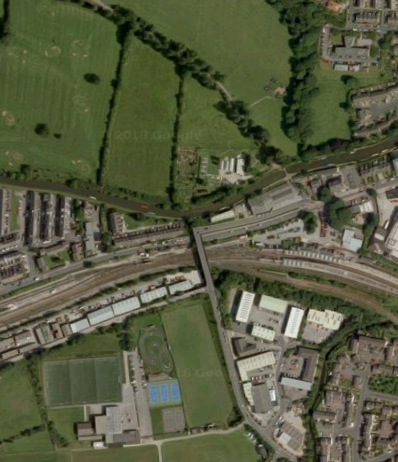
Start
Car Park

