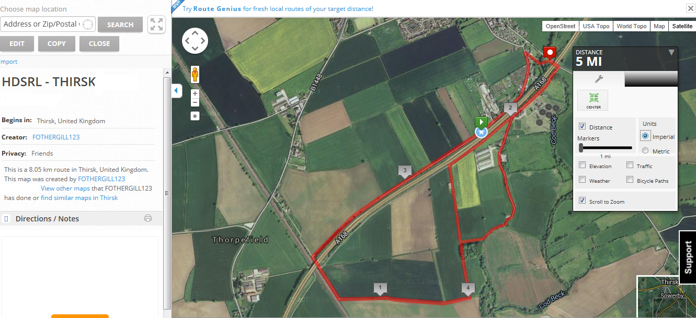
THIS IS A 5 MILE ROUTE; starting at the white star (with blue background); postcode YO7 1JS. Heading towards the 1 mile mark at ‘4’ (ie the 4 mile mark on second lap) the runners turn the corner then head straight forward taking second right heading towards the (red square) and then back to the (white star). The route then goes to the 4 mile mark, this time taking the first right turn and heading towards the finish (red square).
Elevation is on the next page
Toilets, changing facilities and catering (post race supper) are located at Thirsk Athletic Club (TAC), Newsham Road, Thirsk YO7 1QP.
Parking is available at Tesco’s and Lidl on Station Road, Thirsk YO7 1PZ (walking distance from TAC)

